EXERCISE 15
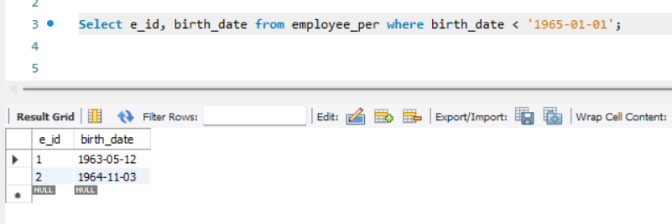
- List all employee ids and birth dates who were born before 1965.

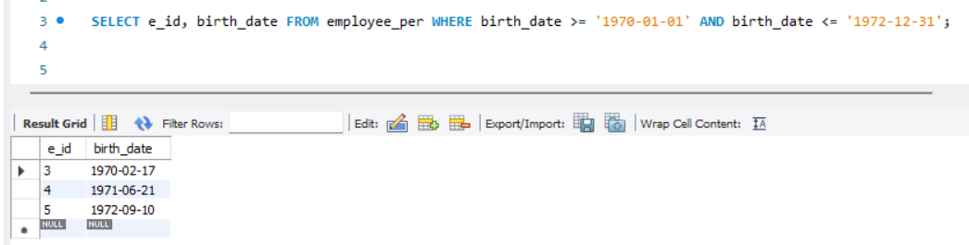
- Display Ids and birth dates of employees born in and between 1970 and 1972.

